Cryopreservation of Stem Cells: Evaluating Approaches for Clinical Potential
POSTED ON FEBRUARY 15, 2015 UPDATED ON FEBRUARY 16, 2015
Despite a growing number of publications discussing various aspects of stem cell cryopreservation, a clear understanding of an optimal set of guidelines, including protocols and, most importantly, cryopreservation solutions that are clinically-suitable is still lacking. The unpredictable behavior and differing biophysical characteristics of different cell types has made making such generalizations less straightforward, as an understanding of individualized cell behavior is becoming of increasing importance.
A recent study by the University of Leuven in Belgium sought to bring some more clarity to these issues. The authors compared seven different freezing and thawing protocols using human amniotic fluid-derived stem cells.
These were:
- (1) 10% dimethyl sulfoxide (DMSO)
- (2) 2.5% DMSO, caspase inhibitor, and catalase
- (3) 5% glycerol, caspase inhibitor, and catalase
- (4) sperm freezing medium
- (5) slow-freezing solution
- (6) ethylene glycol, sucrose, and Ficoll 70
- (7) vitrification solution
Medium 4, sperm freezing medium, was Irvine Scientific’s TYB Freezing Medium, solution 6 was Vitrolife’s FreezeKit medium, while the vitrification solution (7) was Vitrolife’s RapidVit vitrification kit.
While protocols 1, 2, 5 and 6 resulted in successful recovery of hAFSCs based on live/dead assay, a lower CD marker expression profile was much weaker for protocol 2.
Expression levels of GAPDH, Oct-4, SOX17, vimentin, KSP and NCAM showed increased SOX17 gene expression for protocols 1, 2 and 6 compared to the unfrozen control samples.
Taking all of the results into account, the authors identified approaches 1, 5 and 6 as being superior in terms of recovery of cells by yielding a significant amount of cells with strong surface marker expression.
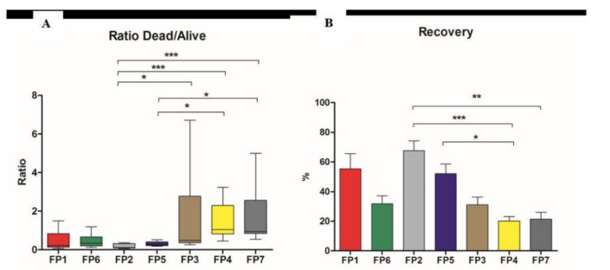

Out of these, the slow-freezing solution (5) was identified by the authors as being the most robust in terms of cell recovery and desirable properties after thawing, and recommendations were made as to its clinical use.
While these are preliminary results that apply to stem cells derived from amniotic fluids, the paper raises important points about the development of freezing solutions by highlighting the important fact that cell-specific behavior does not necessarily show consistency across a range of assays when analyzing treatment response and that multiple analyses need to be considered as a whole.
At Akron, we have been investigating a range of new solutions for cell cryopreservation that are both DMSO-based as well as DMSO-free and have developed a strong know-how of products and solutions for various cell types, particularly those that are free from DMSO. If you have any questions or need help understanding your options for cell cryopreservation (without or with DMSO), feel free to get in touch with us via email at info@akronbiotech.com.

